

**BAIST Consulting Services**

Leaders in Innovation and Integration

Project Plan Case Study

BAIS3020

Fall 2013

**The Task:**

Using the following case study you will act as the project manager and consultant for BAIST Consulting Services (BCS.com) working to implement a technology solution for the ACME Corporation. Your project plan will be the guiding document for this fictitious organization’s project. Your plan will include the elements covered in class and will make use of the several templates provided to you. It is assumed that this will be the document as it would exist at the beginning of the project, thus there will be elements that are not fully detailed in your plan. For example we will have an Initial Scope Statement vs. a Scope Statement. In addition as this is the beginning of the project, there will be no “Lessons Learned” document.

This document will represent the deliverable for BAI540 and is worth 20% of the course mark. See the marking guide at the end of this case study for information related to the grading of this paper.

You will be responsible for turning in a hard copy and soft copy of this assignment – your Project Plan.

**Background:**

You have been assigned to manage a project for BAIST Consulting Services (BCS.com). BCS has won a recent contract to work for the ACME Corporation. ACME is the global leader in unique tools and weapons used by cartoon villains around the world. Established in 1922, ACME has a delivery system that is second to none. However their ordering and internal distribution system has changed little in almost 90 years.

The following samples are only a few of the diverse products ACME Corporation offers:

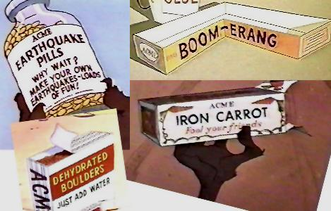 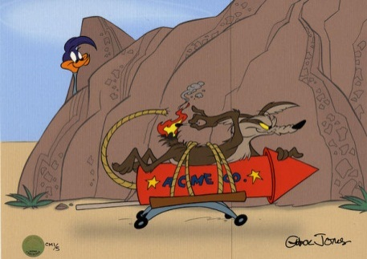 

ACME has perfected the mail order process for distributing their products, especially to the remote locations their villainous customers prefer. However, times have changed and they have noticed a marked drop in market share as their loyal customer base is increasingly turning to companies that provide inferior products but a superior customer experience primarily through e-commerce. Online ordering, web catalogs, community forums, product video demos, and a social networking presence are all contributing to ACME’s reduction in revenue.

ACME has offices in Edmonton (HQ), testing facilities Rachel, Nevada, and manufacturing centers in Hyderabad, India and GuangMing, China.

The systems within these four offices are not supported and are of warranty in some cases and in other cases are more current but poorly configured. The goal of CEO Chuck Jones is to “have the entire organization completely connected, on a uniform platform using the latest technology.” “We will also be unveiling our company to the online community, making our products available anytime, anywhere, to anyone… our market is the world!”, adds Jones.

You have visited the head office of ACME on several occasions interviewing users, IT staff, and the leadership team. You have compiled a table that captures their input. Your job is to compile a project plan that will take this company from its current state to its desired state.

**Desired State / Current State:**

|  |  |
| --- | --- |
| **Desired State** | **Current State** |
| **PC and Network Infrastructure** |  |
| Ratio of PCs to employees - 350 : 350 | 75 : 350 |
| Network Infrastructure: Gigabit Switched Ethernet | 10Mbps with managed hubs |
| Full connectivity to Internet | Only HQ had internet connection |
| Uniform desktop environment (Windows 7 Pro) | HQ – 80%XP, 20% Vista  Rachel – 100% Vista  Hyderabad – 100% NT 4.0 Workstation  GuangMing – 70% Windows 98, 30% XP |
| Standard PC desktop platform (Dell, HP, or Lenovo) | Mixed vendors and no-name clones |
| **Server Infrastructure** |  |
| Industry standard server platform (Enterprise Linux or Microsoft Server 2008)  Need to migrate data from SQL 7.0 | One DB server in Edmonton running SQL 7.0 on Windows 2000 for inventory control and accounting. |
| Enterprise database software available in each centre | See above |
| **Security Needs** |  |
| Enterprise class firewalls for each office and a DMZ for HQ | Residential firewall at HQ (Linksys BEFSR41)  No Internet at the GuangMing or Hyderabad offices |
| VPN capability between offices | N/A |
| **Intranet** |  |
| All current paper forms and communications would be available on Intranet | N/A |
| Inside sales staff would have access to web based order and inventory system from desktop | N/A |
| **DMZ / e-Commerce solution** |  |
| All web traffic destined for the e-Commerce gateway will be routed to servers behind the firewall. Web server will have real-time connection to the inventory database. Pick and shipping instructions will be generated by the successful customer transaction. | N/A |
| **Web Presence** |  |
| ACME currently has no website. ACME customers are young and trend oriented and satisfying their tastes will require the latest in web technology and design | N/A |

**Marking Guidelines**

All project plans will be submitted in a document portfolio (not a duo tang). Students will be responsible for ensuring that the various templates utilized throughout this project plan are formatted in a consistent fashion – in the real world this is referred to as a corporate graphics standard. This includes font, headings, margins, table styles, page numbering, footers, etc.

You are to include the outputs from each of the knowledge areas in your project plan and also to include supporting documentation as described in the Kathy Scwalbe book “Information Technology Project Management 6e or 7” or the “PMBOK 2008/2012”.

In particular please review (Based on the revised 6e edition) Chapter 3 The Project Management Process groups, Table (3-7) Planning Process and outputs (pg. 97-98) and table (3-18) Templates by process groups (pg. 118 – 121) and chapter 4 in particular the section on “Developing a project plan” (pg. 151 – 155)

Also, use the templates provided in Moodle.

Note: (not all outputs from the knowledge areas are necessary if it’s not applicable to you project.)

Below is a **basic marking guide**

|  |  |  |
| --- | --- | --- |
| Project Plan Element | Expectation | Mark |
| Cover page, table of contents, binding, and presentation | Proper binding – see BAIST major document guidelines, cover page, table of contents, formatting, page numbering, overall professionalism of document | **15** |
| Business Case | Write a brief business case for the project. Use the template provided for guidance | **10** |
| Integration Management | Please review each knowledge area for outputs | **10** |
| Scope Management | Please review each knowledge area for outputs | **15** |
| Time Management | Please review each knowledge area for outputs and ensure you create a Gantt chart, network diagrams etc. | **15** |
| Cost Management | Please review each knowledge area for outputs | **15** |
| Quality Management | Please review each knowledge area for outputs | **10** |
| Human Management | Please review each knowledge area for outputs | **10** |
| Communication Management | Please review each knowledge area for outputs. | **10** |
| Risk Management | Please review each knowledge area for outputs | **10** |
| Procurement Management | Please review each knowledge area for outputs | **10** |
| Change Control Plan | Create a plan for how you are going to evaluate change requests and what the process will be for request, approval and implementation | **5** |
| Change Request Template | Create the tool you will use to begin the Change Process. Use the template provided for guidance | **3** |
| Client Acceptance Form | The wrap-up document. When you have completed the project, this is the final step. Uses the template provided for guidance, **but customize it for your project.** | **3** |
| Transference to operations | How will you transfer this project to operations? | **10** |
| Glossary of Terms | Create a glossary of terms that are specific to the project and may need explaining to the **average reader** not familiar with the technology you are proposing | **5** |
|  | **SUBJECT to CHANGE** |  |
|  |  |  |